
Surface Pro tech specs.
Take a look at this table for all the tech specs. Everything you need to know about unleashing the creative power of Surface Pro can be found right here.
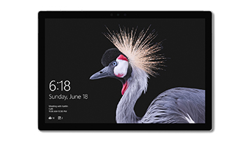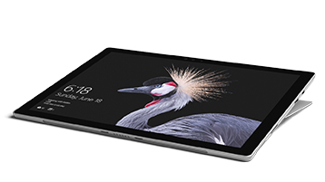
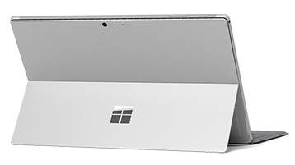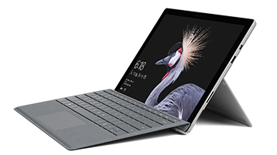

Tech specs
Processor | Intel® Core™ 7th-generation m3, i5, or i7
Memory | 4GB, 8GB, or 16GB RAM
Storage² | Solid state drive (SSD) options: 128GB, 256GB, 512GB, or 1TB
Display | Screen: 12.3” PixelSense™ DisplayResolution: 2736 x 1824 (267 PPI)Aspect Ratio: 3:2Touch: 10 point multi-touch
Graphics | Intel® HD Graphics 615 (m3)Intel® HD Graphics 620 (i5)Intel® Iris™ Plus Graphics 640 (i7)
Security | TPM chip for enterprise securityEnterprise-grade protection with Windows Hello face sign-in
Software | Windows 10 ProOffice 30-day trial
Battery Life | Up to 13.5 hours of video playback¹
Dimensions | 11.5” x 7.9” x 0.33” (292 mm x 201 mm x 8.5 mm)
Sensors | Ambient light sensorAccelerometerGyroscope
What’s in the box | Surface ProPower SupplyQuick Start GuideSafety and warranty documents
Weight** | m3: 1.69 lbs (768 g)i5: 1.70 lbs (770 g)i7: 1.73 lbs (784 g)
Connections | 1 x Full-size USB 3.0microSDXC card readerSurface Connect3.5mm Headphone jackMini DisplayPortCover port
Camera, video and audio | Windows Hello face authentication camera (front-facing)5.0MP front-facing camera with 1080p Skype HD video8.0MP rear-facing autofocus camera with 1080p Full HD videoDual microphones1.6W Stereo speakers with Dolby® Audio™ Premium
Wireless | Wi-Fi: IEEE 802.11 a/b/g/n/ac compatibleBluetooth Wireless 4.1 technology
Exterior | Surface Pen*Surface Keyboard*Surface Mouse*
Warranty | 1-year limited hardware warranty

